TASK 1:
Jenkins Familiarization Objective:
Understand Jenkins UI and basic navigation Tasks:
1. Open Jenkins Dashboard in browser

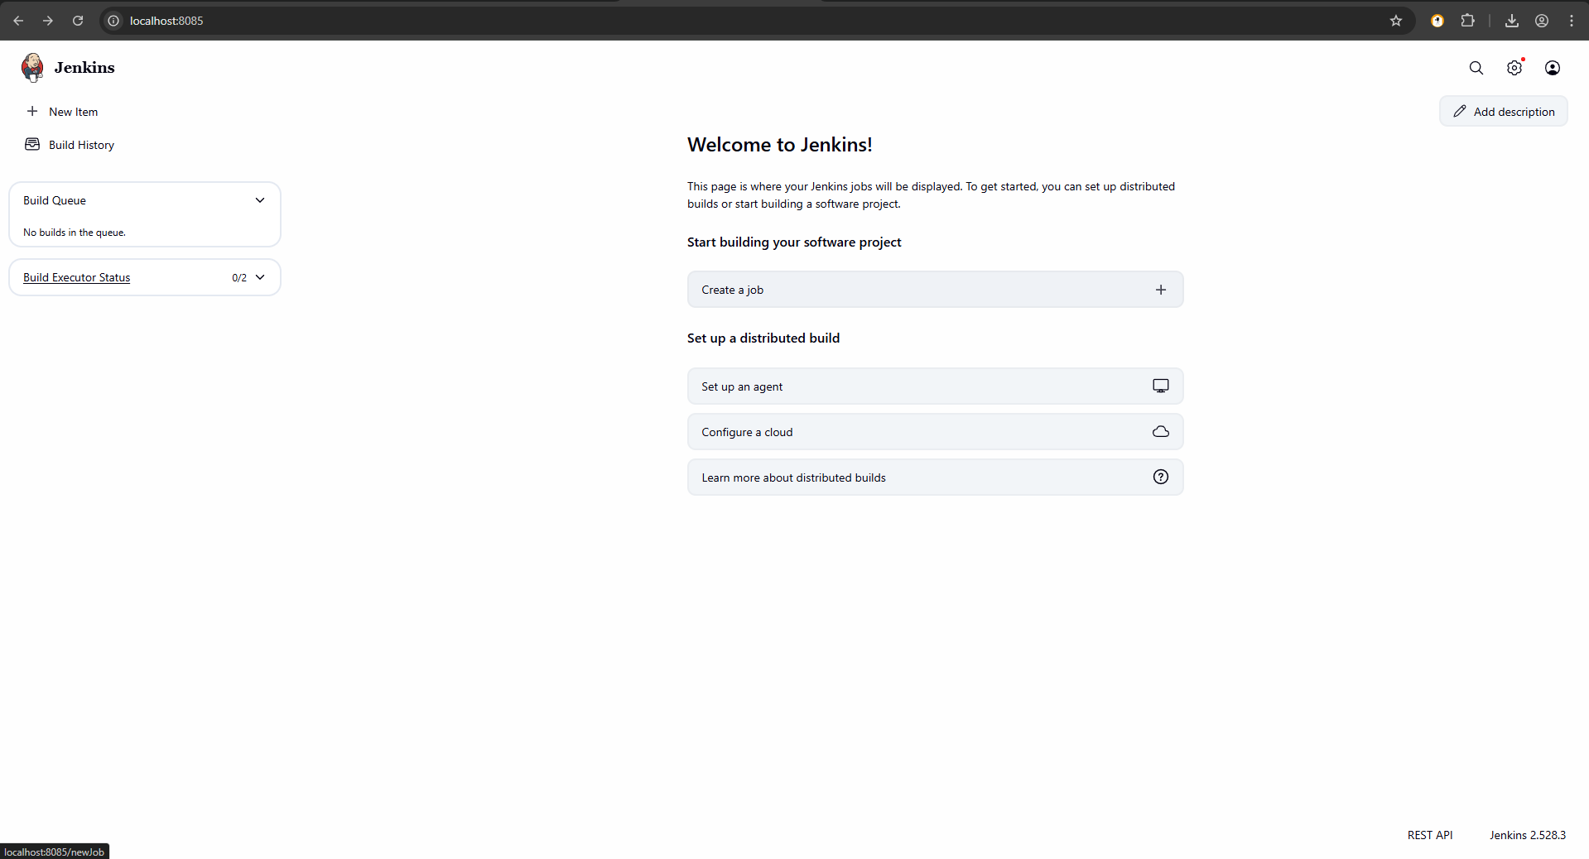

2. Identify:
o Dashboard

o Manage Jenkins
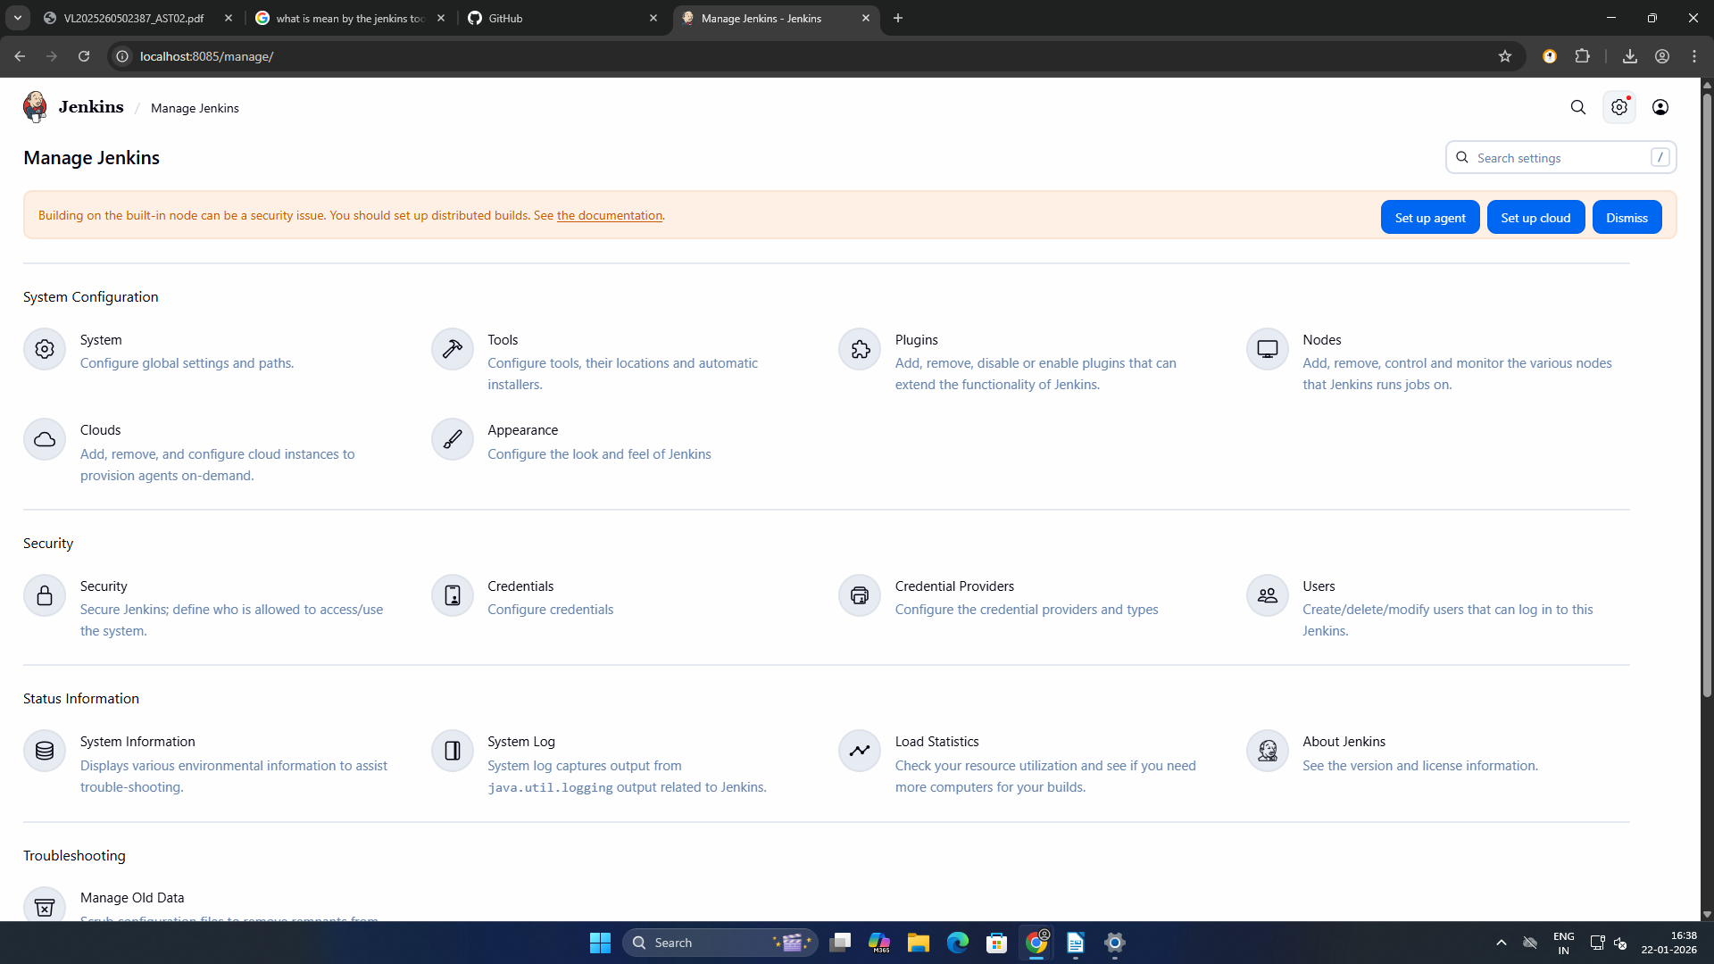
o New Item

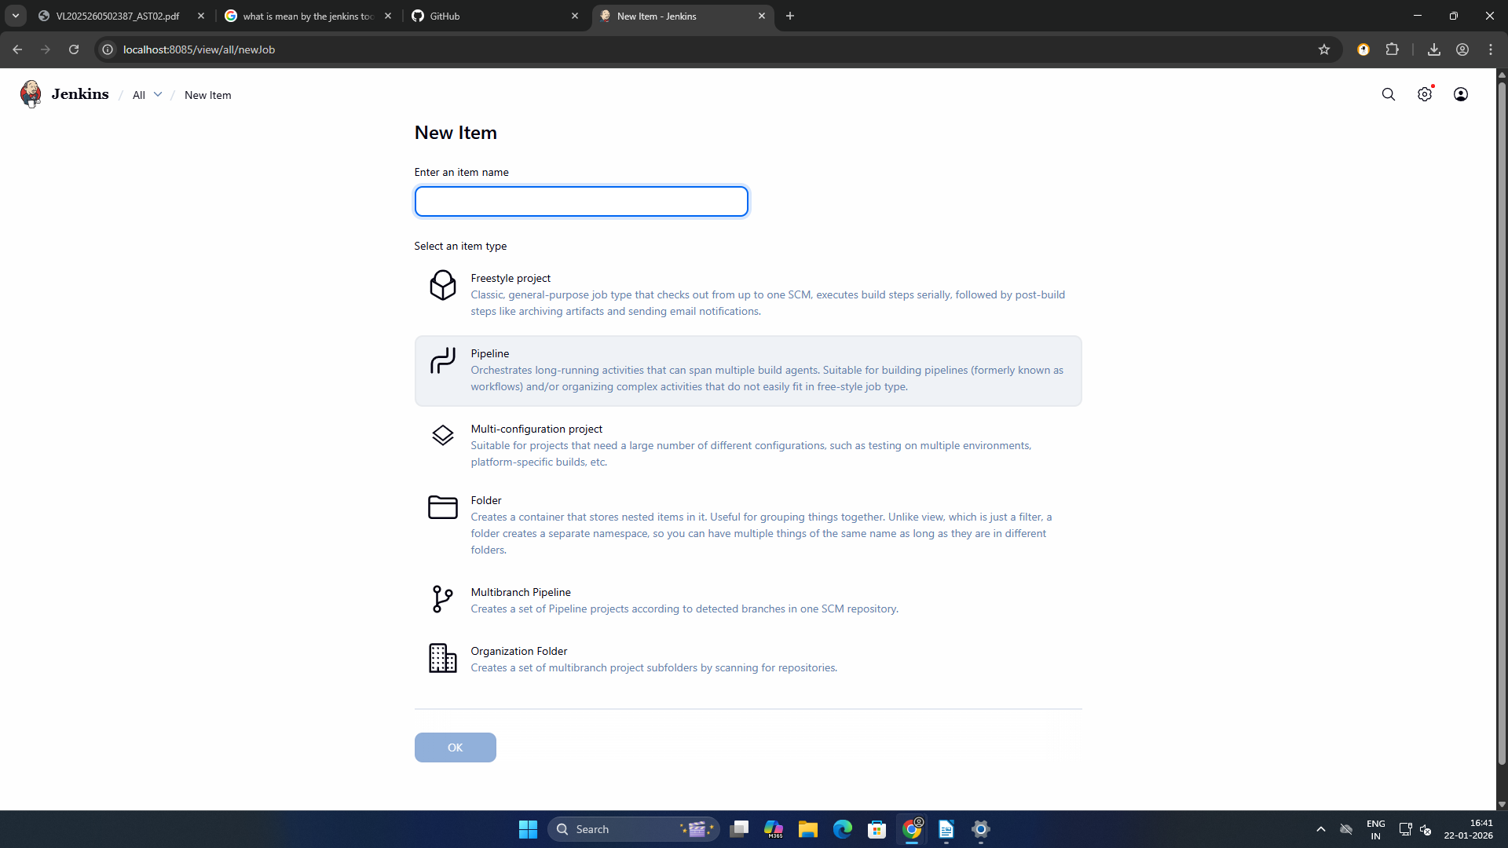

o Build History

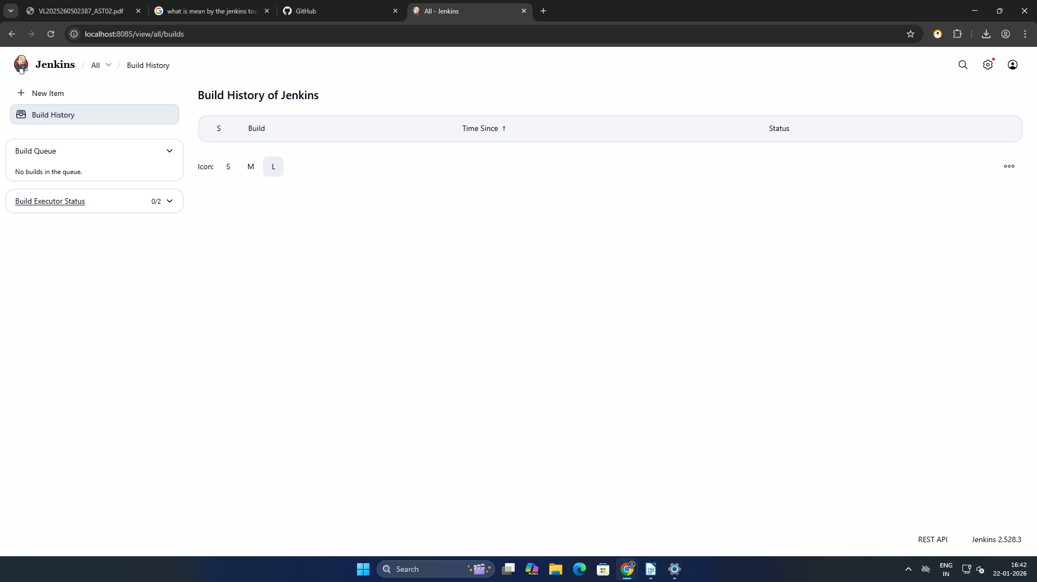

3. Check Jenkins version

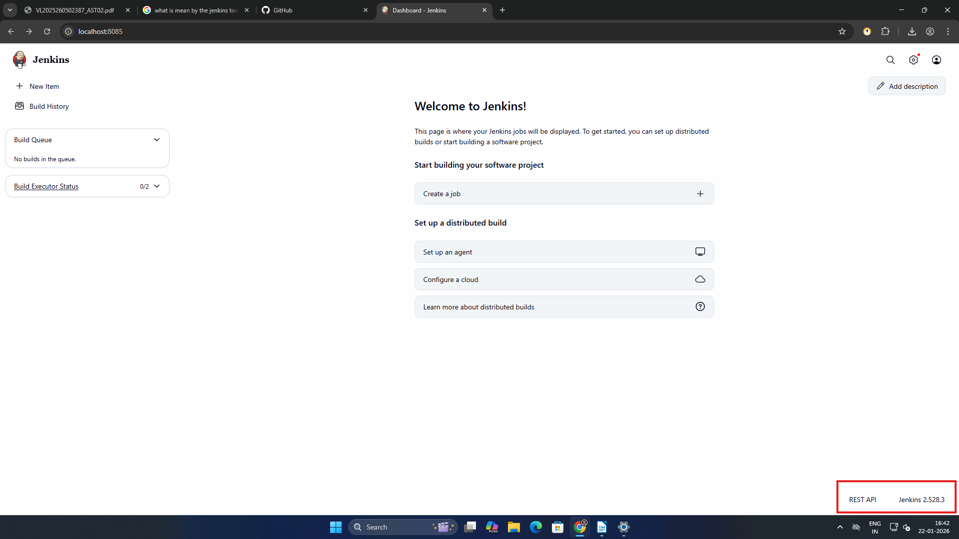

TASK 2:
Create First Freestyle Job Objective:
Create and run a Jenkins job Tasks:
1. Create a Freestyle project named Hello-Jenkins
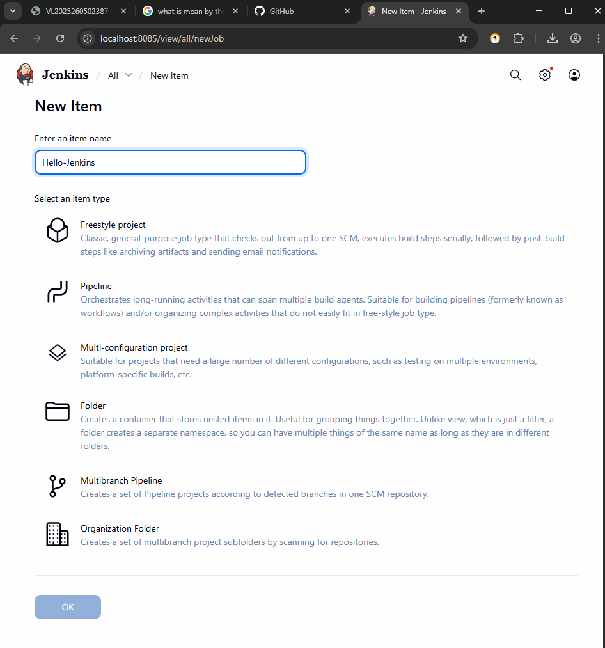

2. Add a description

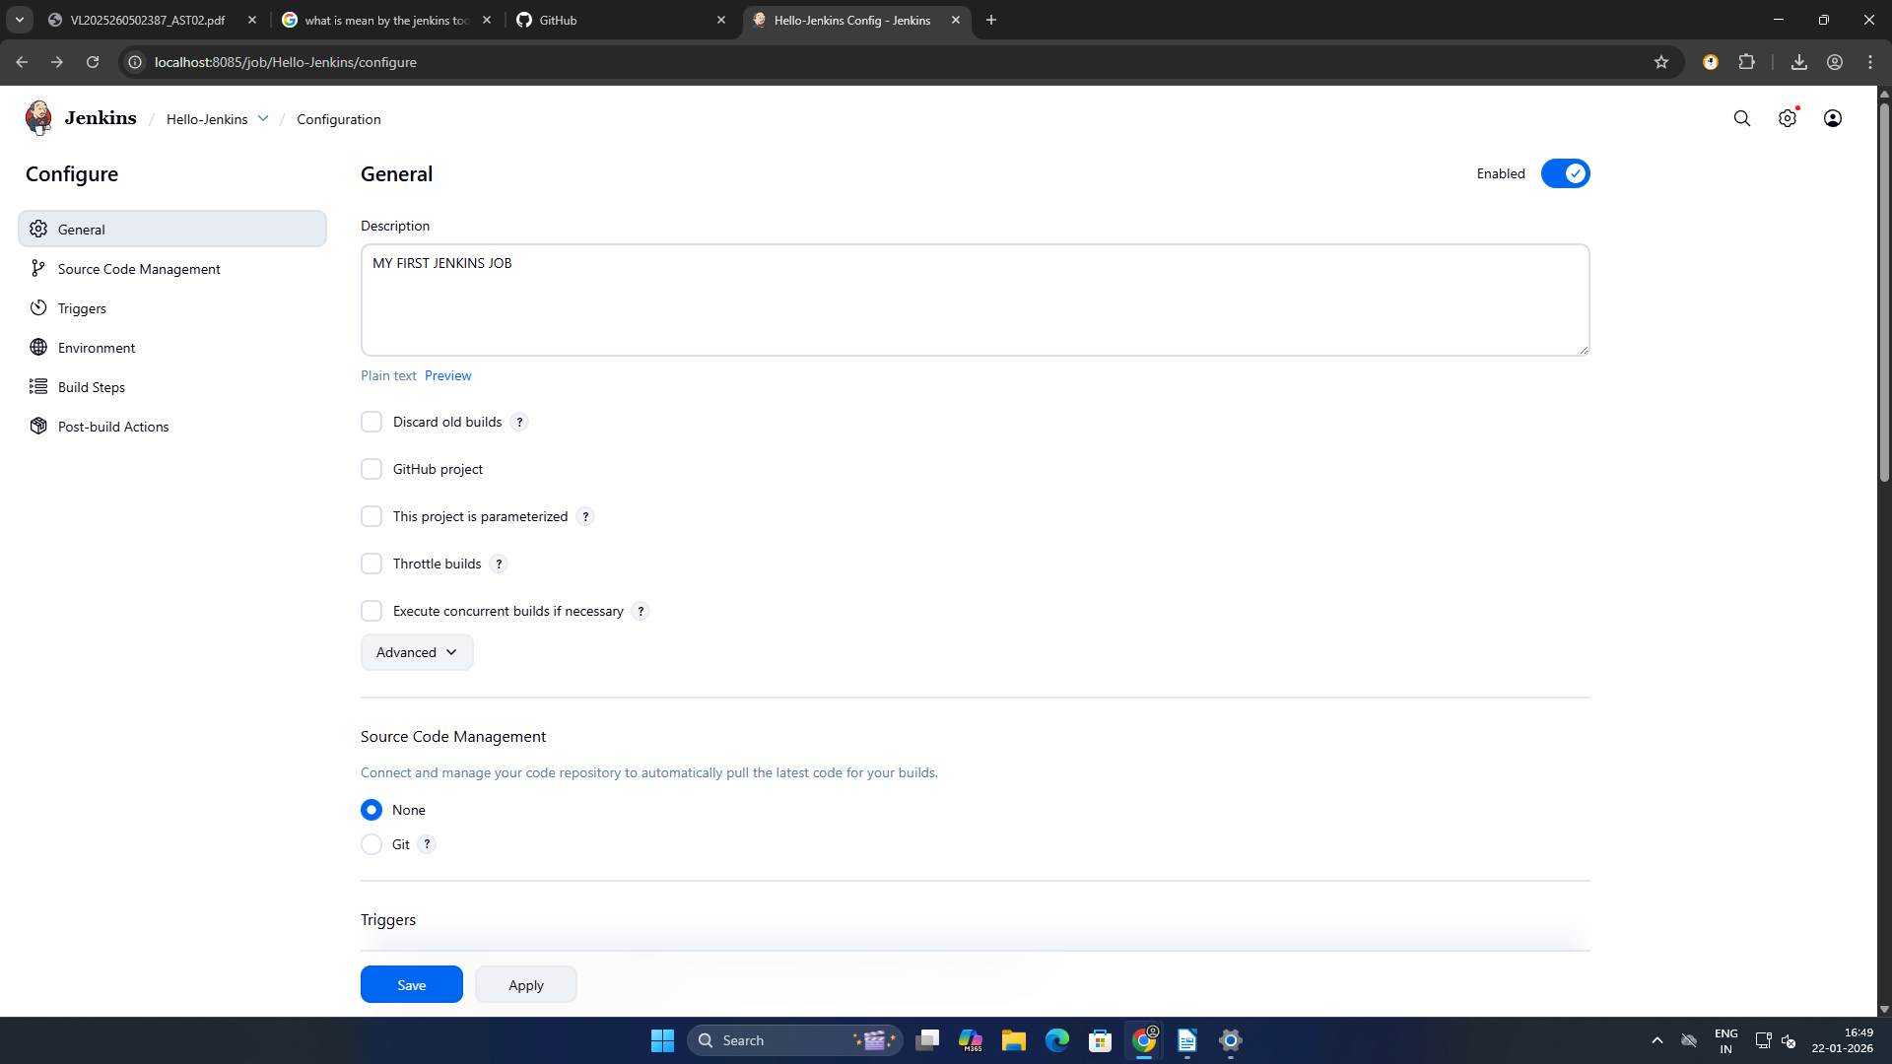

3. Add build step:

o Execute shell / Windows batch command

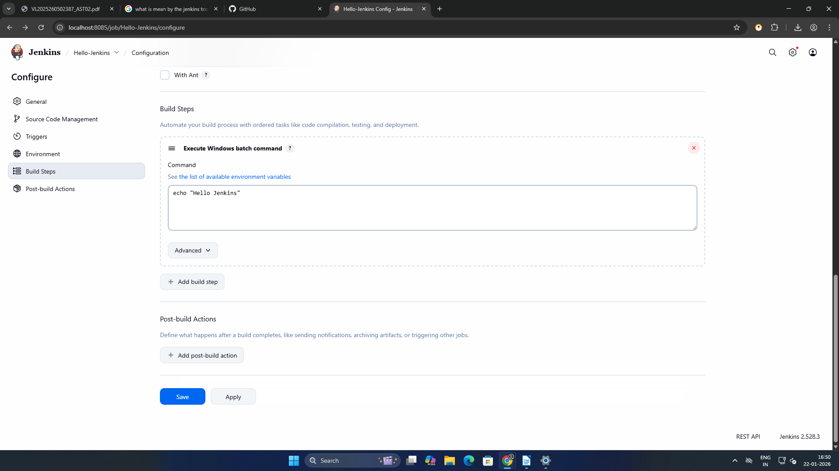

o Print "Hello Jenkins"
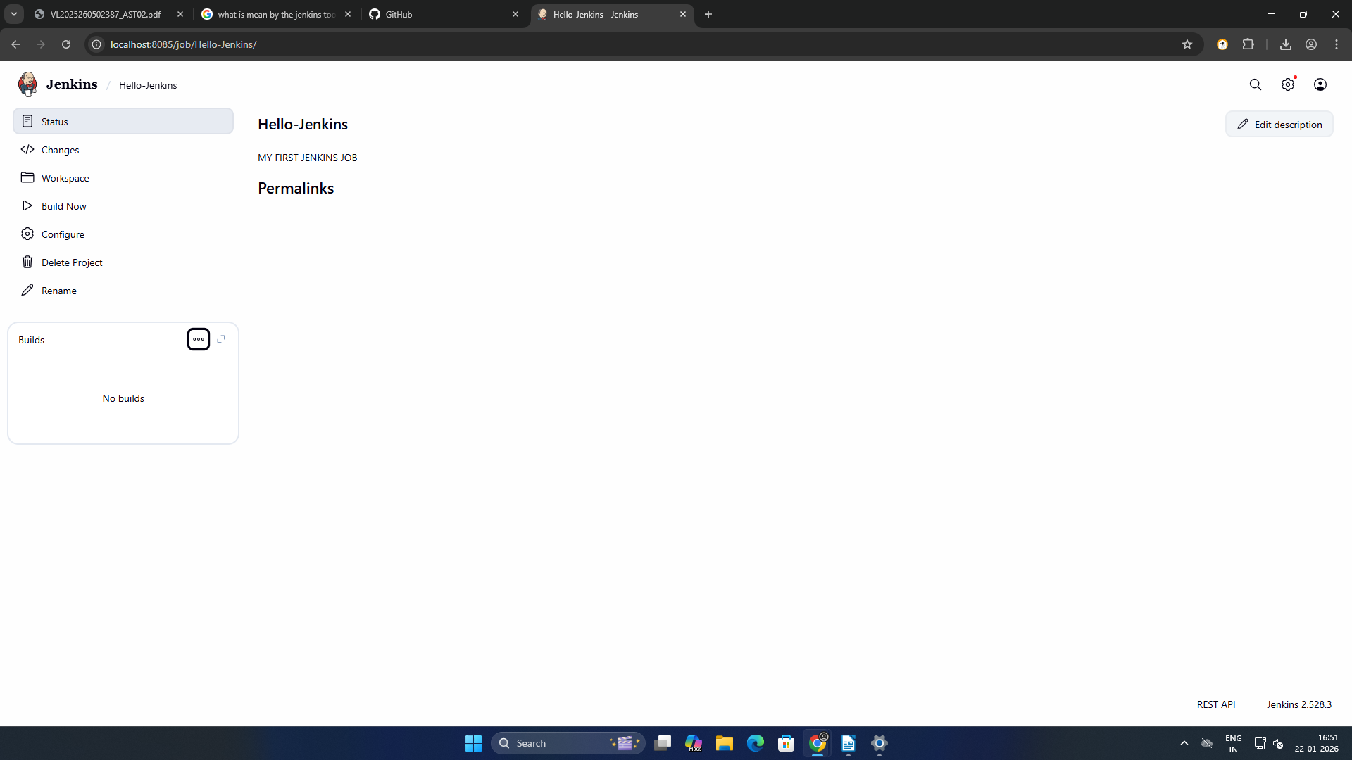
4. Build the job manually
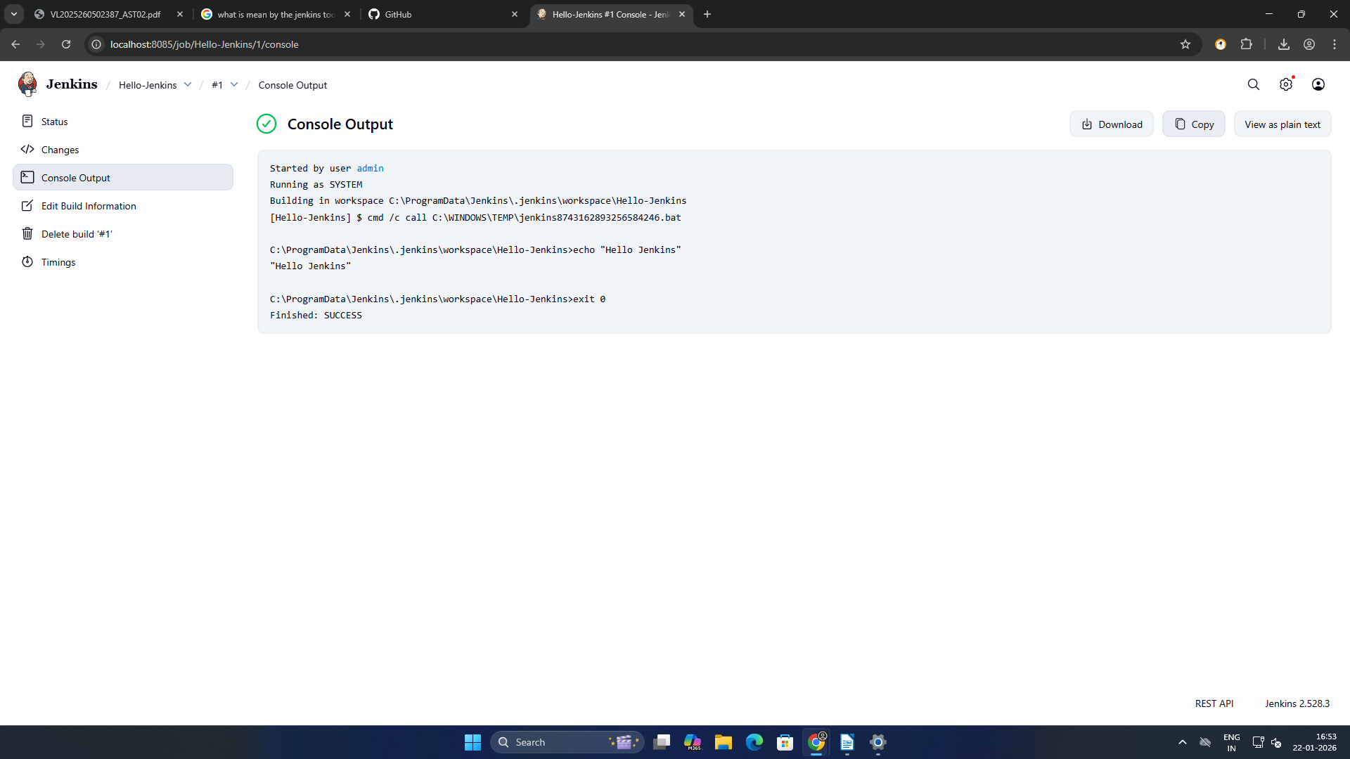

Expected Output: • Console output showing message

TASK 3:
Jenkins Workspace & Commands Objective:
Understand workspace usage Tasks:
1. Navigate to job workspace

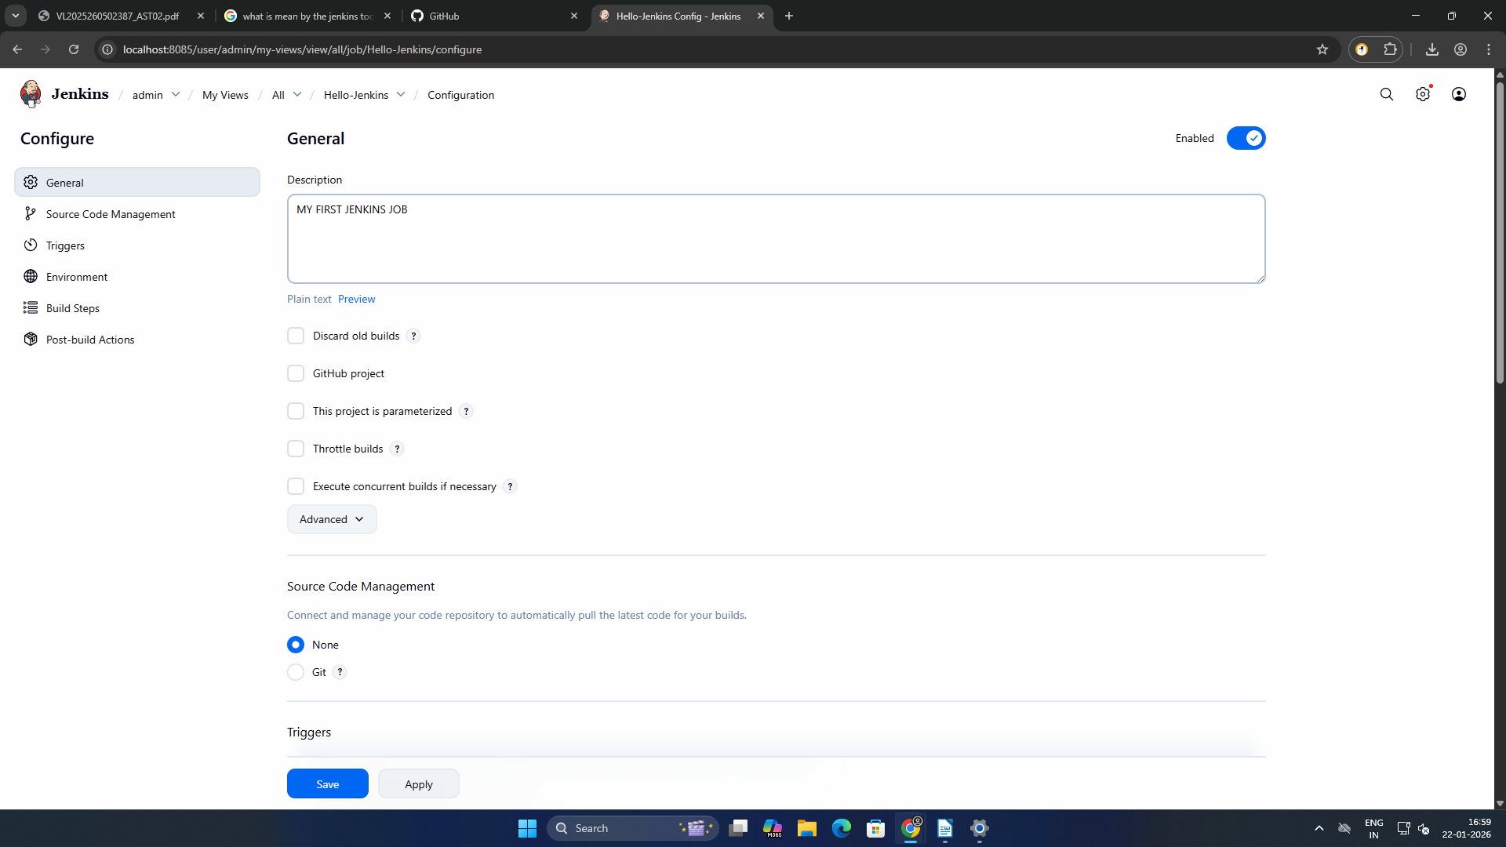
2. Create a text file using build step

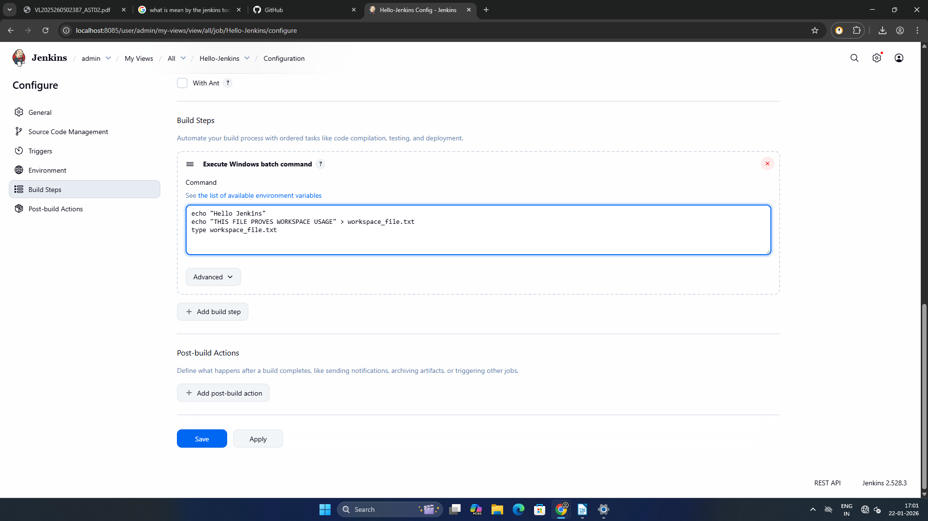

3. Display file contents in console

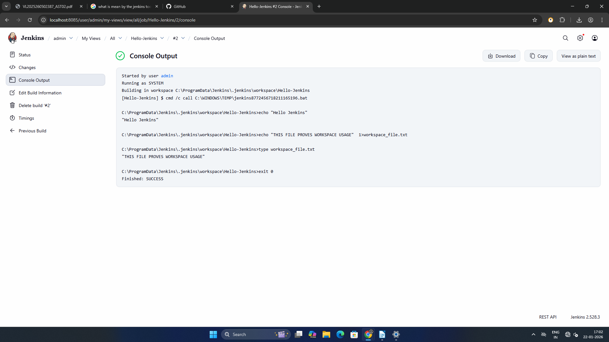
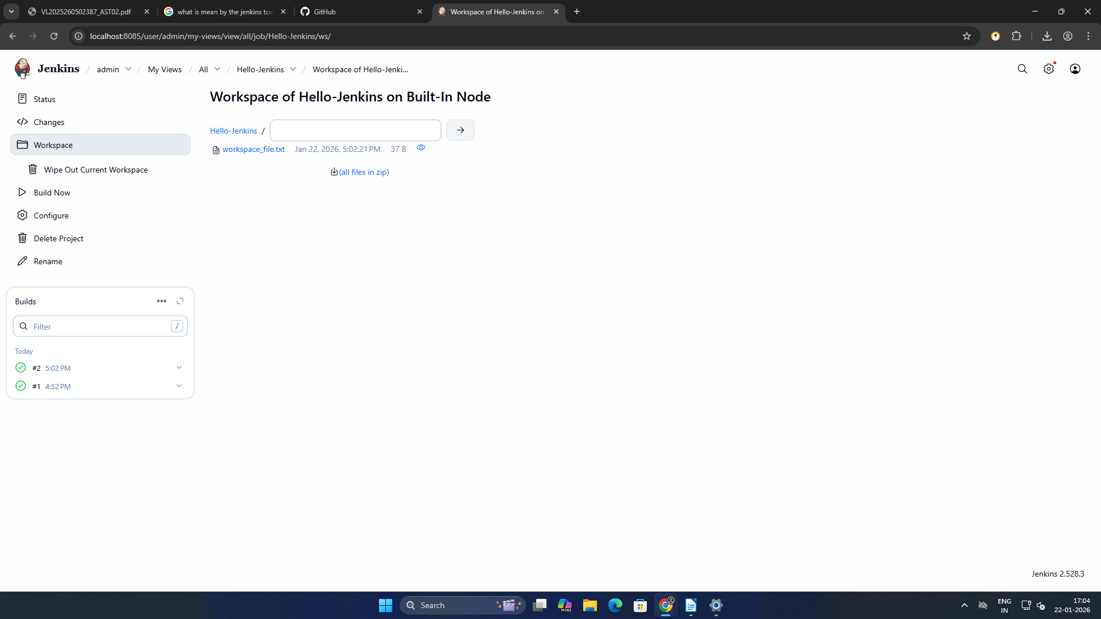

Expected Output: File created inside workspace

TASK 4:
Git Integration Objective:
Integrate Jenkins with GitHub Tasks:
1. Create a GitHub repository with sample code

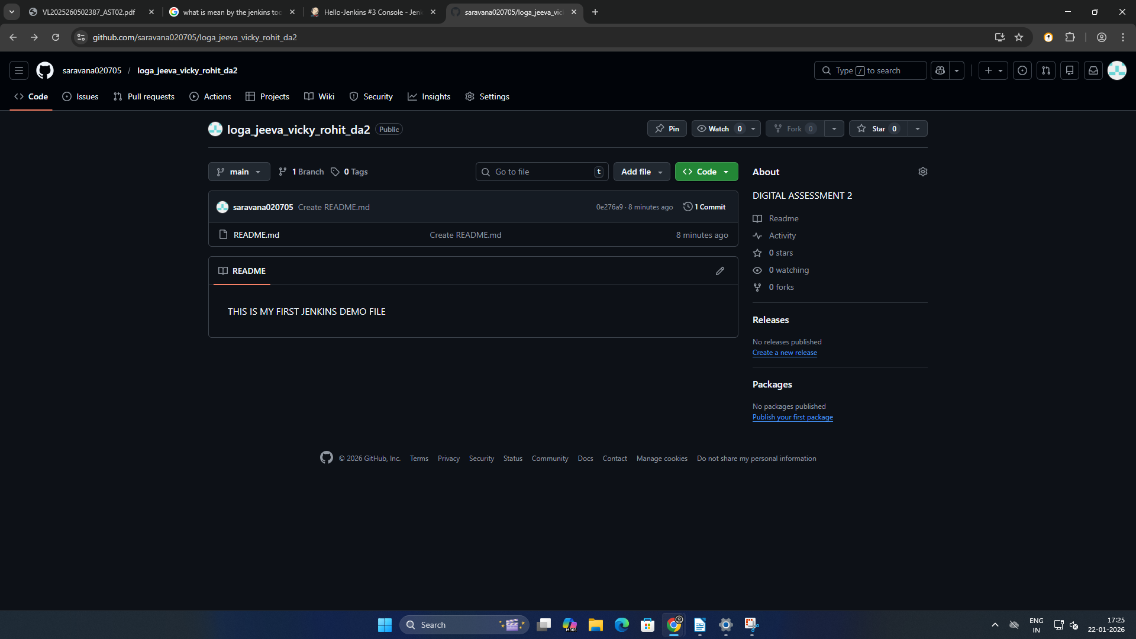
2. Configure Git in Jenkins
3. Add Git repository URL in job
4. Build and verify code checkout
Expected Output: • Source code visible in workspace

